**Assignment 6.2:**

**Problem Statement:**

* **Fetch date and temperature from temperature_data where zip code is greater than**

**300000 and less than 399999**.

**Steps**:

hive> select full_date,temperature from custom.temperature_data where zip>300000 and zip<399999;

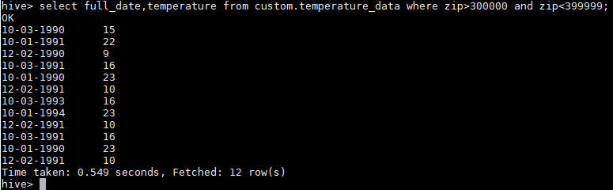

* **Calculate maximum temperature corresponding to every year from temperature_data**

**table.**

**Steps:**

hive> SELECT SUBSTR(full_date, 7, 10), MAX(temperature) FROM custom.temperature_data GROUP BY SUBSTR(full_date, 7, 10);

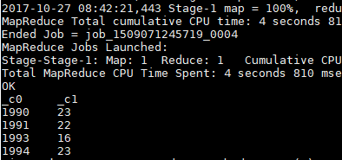

* **Calculate maximum temperature from temperature_data table corresponding to those**

**years which have at least 2 entries in the table.**

**Steps:**

hive> SELECT SUBSTR(full_date, 7, 10) AS YEAR,MAX(temperature) AS TEMPERATURE FROM custom.temperature_data GROUP BY SUBSTR(full_date, 7, 10) HAVING count(SUBSTR(full_date, 7, 10)) >=2; 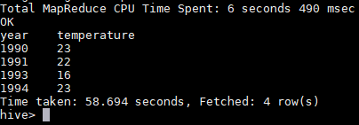

* **Create a view on the top of last query, name it temperature_data_vw.**

**Steps:**

hive> CREATE VIEW temperature_data_vw AS SELECT SUBSTR(full_date, 7, 10) AS YEAR,MAX(temperature) AS

> TEMPERATURE FROM custom.temperature_data GROUP BY SUBSTR(full_date, 7, 10) HAVING count(SUBSTR(full_date, 7, 10)) >=2;

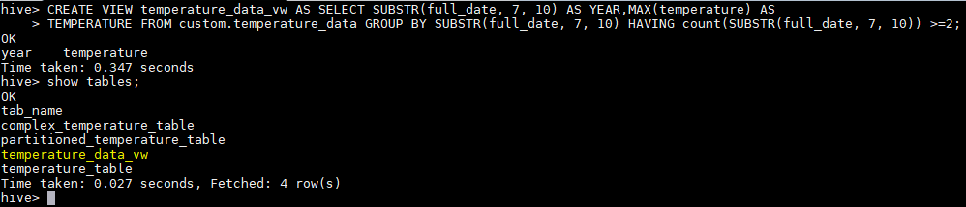

* **Export contents from temperature_data_vw to a file in local file system, such that each**

**file is '|' delimited.**

**Steps:**

hive> INSERT OVERWRITE LOCAL DIRECTORY '/home/acadgild/hive/temperature_data_vw'

> ROW FORMAT DELIMITED

> FIELDS TERMINATED BY '|'

> select * from temperature_data_vw;

